IET DEPARTMENT



Submitted By: Sumama Rahim
Reg# F24BSCS039
Dated: 12/12/2025
Program: BS CS
Course: Data Structures
Submitted To: Ms. Engr. Afifa Zaffar

Lab 6: Circular Linked List
Marks Distribution/Rubrics:
- Logic building(own)=2 marks
- Running/Correct output=1 marks
- Implementation of Circular link list 5 marks.
- Required functionality=2 marks
- Copy (internet/any other source)= 0 to -ve marking)
Objective
- Circular Link List Introduction
- Insertion in Circular Link List
- Deletion in Circular Link List
PRACTICE TASKS
Task 1: Circular linked List Task:
Consider the above-given code of a doubly circular link list. Now add the following function to it
- The function called InsertAtBegin() that adds a node at the beginning of the Circular Linked list.
- The function called DeleteNode() to delete a node in Circular Linked List. (consider all scenarios, as we discussed in the previous lab)
- The function called CountNode() that displays the number of nodes in the Circular Linked List
Solution:

/**
* Date: 12/11/2025
* Sumama Rahim
* Reg# F24BSCS039
* Course: Data Structures
* Instructor: Engr. Ms. Afifa
*/

class CircularList {
// Represents the node of list.
public class Node {
int data;
Node next, prev;
public Node(int data) {
this.data = data;
}
}
// Declaring head and tail pointer as null.
public Node head = null;
public Node tail = null;
// Function to insert node in the list
public void addNode(int data) {
// List is empty so create a single node first
if (head == null) {
Node new_node = new Node(data);
new_node.next = new_node.prev = new_node;
head = new_node;
return;
} else {
// find last node in the list if list is not empty
Node last = head.prev; // previous of head is the last node
// create a new node
Node new_node = new Node(data);
// next of new_node will point to head since list is circular
new_node.next = head;
// previous of head will be new_node
head.prev = new_node;
// change new_node.prev to last
new_node.prev = last;
// Make new node next of old last
last.next = new_node;
// last = new_node;
}
}

/**
* start of my code: Solution
* *********************************************************************
*/
// i. Insert at Beginning ***
public void InsertAtBegin(int data) {
if (head == null) {
addNode(data);
return;
}
Node last = head.prev;
Node new_node = new Node(data);
new_node.next = head;
head.prev = new_node;
new_node.prev = last;
last.next = new_node;
head = new_node;
}

// 2. Deleting node - all scenarios
public void DeleteNode(int value) {

// scenario 1: empty linked list
if (head == null) {
System.out.println("Linkd list is empty - can't delete!");;
}
Node S = head;
// scenario 2: only one node
if (S.data == value && S.next == head) {
head = null;
}

// scenario 3: traversing until value found
while (S.data != value) {
S = S.next;
if (S == head) {
System.out.println("Node not found.");
return;
}
}
S.prev.next = S.next;
S.next.prev = S.prev;
}

// 3. nodes counting
public void CountNode() {
if (head == null) // checking if linked list is empty
{
System.out.println("\nNo nodes exists - empty linked list!");
}
int count = 1;
Node S = head;
while (S.next != head) {
count++;
S = S.next;
}
System.out.println("\nTotal Nodes = " + count);
}

/** End of my code - Solution
* ***********************************************
*/

// Print forward
public void printNodes() {
Node temp = head;
// traverse in forward direction starting from head
while (temp.next != head) {
System.out.println(temp.data + "");
temp = temp.next;
}
System.out.println(temp.data + "");
}

public void ReverseNodes() {
Node last = head.prev;
Node temp = last;
System.out.println("Reverse order List: ");
while (temp.prev != last) {
System.out.println(temp.data + "");
temp = temp.prev;
}
System.out.println(temp.data + "");
}

public static void main(String[] args) {
CircularList CL = new CircularList();
CL.addNode(10);
CL.addNode(20);
CL.addNode(30);
CL.addNode(40);
System.out.println("Original List:");
CL.printNodes();
// Insert at beginning
CL.InsertAtBegin(5);
System.out.println("\nAfter InsertAtBegin:");
CL.printNodes();
// start of my code - methods calling //
// Delete a node
int toDelete = 20;
CL.DeleteNode(toDelete);
System.out.println("\nAfter Deleting " + toDelete + ":");
CL.printNodes();
// Count nodes
CL.CountNode();
// end of my code - methods calling //
System.out.println("\nReverse List:");
CL.ReverseNodes();
}
}

Output:
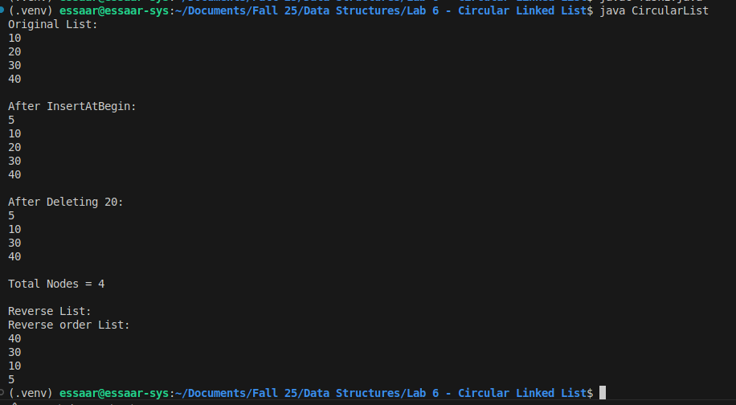

Task 2:
In recording scores for a golf tournament, we enter the name and score of the player as the player finishes. i.e., Players’ names and Scores For that we have to design a structure that keeps the information in a way that each player has information about the player next to it and the one behind it as well. Take care that the Last player has information about the first player and the first player has information about the last player also.
Implement the above scenario using an appropriate data structure.
Your Application should do the following
- Add a new Player (at the end)
- Delete a player ( user enters the name of the player to be deleted, it can be present at any location)
- Display the whole list (all players with their scores)
- Display the player with the lowest and max scores in the list.
- Display count or all those players having the same scores
- Display Backward From a player ( it should print data of all the players behind a
player)

Solution:
/** *
* Date: 12/11/2025
* Course: Data Structures
* Instructor: Engr. Afifa Zafar
*/
import java.util.Scanner; // to import Scanner class to take input from user
class GolfTournament {
class Player {
String name;
int score;
Player next, prev;
public Player(String name, int score) {
this.name = name;
this.score = score;
}
}

private Player head = null;
private Player tail = null;

// Add at END
// -------------------------------------------------------
public void addPlayer(String name, int score) {
Player newPlayer = new Player(name, score);
if (head == null) {
newPlayer.next = newPlayer.prev = newPlayer;
head = tail = newPlayer;
return;
}
newPlayer.next = head;
head.prev = newPlayer;
newPlayer.prev = tail;
tail.next = newPlayer;
tail = newPlayer;
}

// Delete player by name
public void deletePlayer(String name) {
if (head == null) {
System.out.println("List Empty.");
return;
}
Player S = head;
do {
if (S.name.equalsIgnoreCase(name)) {
break;
}
S = S.next;
} while (S != head);
if (!S.name.equalsIgnoreCase(name)) {
System.out.println("Player not found.");
return;
}
// 1 node only
if (S == head && S == tail) {
head = tail = null;
} // deleting head
else if (S == head) {
head = head.next;
head.prev = tail;
tail.next = head;
} // deleting tail
else if (S == tail) {
tail = tail.prev;
tail.next = head;
head.prev = tail;
} // middle node
else {
S.prev.next = S.next;
S.next.prev = S.prev;
}
System.out.println("Player deleted successfully.");
}

// display
// -------------------------------------------------------------
public void display() {
if (head == null) {
System.out.println("List empty.");
return;
}
Player S = head;
do {
System.out.println(S.name + " : " + S.score);
S = S.next;
} while (S != head);
}

// lowest score
// ----------------------------------------------------------------
public void lowestScore() {
if (head == null) {
return;
}
Player S = head;
Player low = head;
do {
if (S.score < low.score) {
low = S;
}
S = S.next;
} while (S != head);
System.out.println("Lowest Score: " + low.name + " -> " + low.score);
}

// highest score
// ----------------------------------------------------
public void highestScore() {
if (head == null) {
return;
}
Player S = head;
Player high = head;
do {
if (S.score > high.score) {
high = S;
}
S = S.next;
} while (S != head);
System.out.println("Highest Score: " + high.name + " -> " + high.score);
}

// Counting Same scorer
// ------------------------------------------------------------------
public void countSameScore(int score) {
int count = 0;
Player S = head;

do {
if (S.score == score) {
count++;
}
S = S.next;
} while (S != head);

System.out.println("Players with score " + score + " = " + count);
}

// displaying in back from specific player
// -----------------------------------------------------------------
public void backwardFrom(String name) {
if (head == null) {
return;
}
Player S = head;
do {
if (S.name.equalsIgnoreCase(name)) {
break;
}
S = S.next;
} while (S != head);
if (!S.name.equalsIgnoreCase(name)) {
System.out.println("Player not found.");
return;
}
System.out.println("Backward from " + name + ":");
Player p = S.prev;
do {
System.out.println(p.name + " : " + p.score);
p = p.prev;
} while (p != S.prev);
}
public static void main(String[] args) {
Scanner sc = new Scanner(System.in);
GolfTournament gt = new GolfTournament();
System.out.println("\nAdding Player");
gt.addPlayer("Sumama", 378); // adds to list
gt.addPlayer("Aqsa", 378); // adds to list
gt.addPlayer("Susan", 371); // adds to list
System.out.println("Delete Player");
System.out.print("Name to delete: ");
gt.deletePlayer(sc.nextLine());
System.out.println("Display all player's List");
gt.display(); // displays all players
System.out.println("Lowest Score");
gt.lowestScore();
System.out.println("Highest Score");
gt.highestScore();
System.out.println("Count of Same Score");
gt.countSameScore(378); // counts players having score = 378
System.out.println("Backward From Player");
System.out.print("Name: ");
gt.backwardFrom(sc.nextLine());
}
}

Output:
- Add a new Player (at the end)
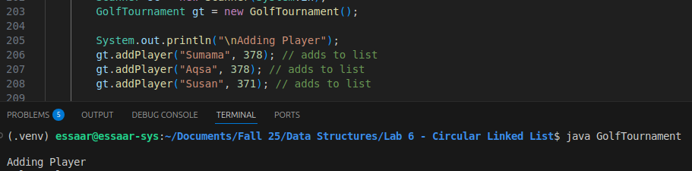
- Delete a player ( user enters the name of the player to be deleted, it can be present at any location)
- Display the whole list (all players with their scores)
- Display the player with the lowest and max scores in the list.
- Display count or all those players having the same scores
- Display Backward From a player ( it should print data of all the players behind a
player)
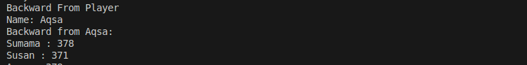

Task 3: Data Entry Operator in a company implementation
Suppose, you are working as a Data Entry Operator in a company. You have created a dataset that contains the names of N employees. Then your supervisor wants you to add, deleted, update, look/search for a particular employee by name. (Consider, every name in the data set is unique).
Now your task is to write a program using a circular singly Link List Data structure which will help you to add, del, and find out the details that your supervisor is looking for.
If an operation is performed successfully then print an appropriate message “added/deleted/found successfully”

Solution:
/**
* Date: 12/12/2025
* Sumama Rahim
* Course: Data Structures
* Instructor: Engr. Afifa Zafar*
*/

import java.util.Scanner; // to take input
class EmployeeList {
class Node {
String name;
Node next;
Node(String name) {
this.name = name;
}
}
Node head = null;
// Add employee record
// ************************************************
public void add(String name) {
Node newNode = new Node(name);
if (head == null) {
head = newNode;
newNode.next = head;
} else {
Node temp = head;
while (temp.next != head) {
temp = temp.next;
}
temp.next = newNode;
newNode.next = head;
}
System.out.println("Added successfully");
}

// Delete employee record
// **************************************************************
public void delete(String name) {
if (head == null) {
System.out.println("List is empty!");
return;
}
Node S = head;
Node prev = null;
do {
if (S.name.equalsIgnoreCase(name)) {
break;
}
prev = S;
S = S.next;
} while (S != head);

if (!S.name.equalsIgnoreCase(name)) {
System.out.println("Employee not found");
return;
}
// only one node
if (S == head && S.next == head) {
head = null;
} // deleting head
else if (S == head) {
Node last = head;
while (last.next != head) {
last = last.next;
}
head = head.next;
last.next = head;
} // deleting in-between
else {
prev.next = S.next;
}
System.out.println("Deleted successfully");
}
// Update employee name
// ***********************************************************
public void update(String oldName, String newName) {
if (head == null) {
return;
}
Node S = head;
do {
if (S.name.equalsIgnoreCase(oldName)) {
S.name = newName;
System.out.println("Updated successfully");
return;
}
S = S.next;
} while (S != head);
System.out.println("Employee not found");
}

// Search employee
// ***********************************************************
public void search(String name) {
if (head == null) {
System.out.println("List empty");
return;
}
Node S = head;
do {
if (S.name.equalsIgnoreCase(name)) {
System.out.println("Found successfully");
return;
}
S = S.next;
} while (S != head);
System.out.println("Employee not found");
}
// Display
// *******************************************************
public void display() {
if (head == null) {
System.out.println("No employees.");
return;
}
Node S = head;
do {
System.out.println(S.name);
S = S.next;
} while (S != head);
}

// menu
// ********************************************************
void menu() {
EmployeeList list = new EmployeeList();
Scanner sc = new Scanner(System.in);
int ch;
do {
System.out.println("\nChoose the option\n1. Add");
System.out.println("2. Delete");
System.out.println("3. Update");
System.out.println("4. Search");
System.out.println("5. Display");
System.out.println("0. Exit");
System.out.print("Choice: ");
ch = sc.nextInt();
sc.nextLine();
switch (ch) {
case 1:
System.out.print("Enter name: ");
list.add(sc.nextLine());
break;
case 2:
System.out.print("Enter name to delete: ");
list.delete(sc.nextLine());
break;

case 3:
System.out.print("Old name: ");
String oldName = sc.nextLine();
System.out.print("Update with name: ");
String newName = sc.nextLine();
list.update(oldName, newName);
break;

case 4:
System.out.print("Enter name to search: ");
list.search(sc.nextLine());
break;

case 5:
System.out.println("\nAll employee's Data");
list.display();
break;
}
} while (ch != 0);
}
}

class Main {
public static void main(String[] args) {
EmployeeList list = new EmployeeList();
list.menu(); // calling the menu
}
}

Output:
Menu
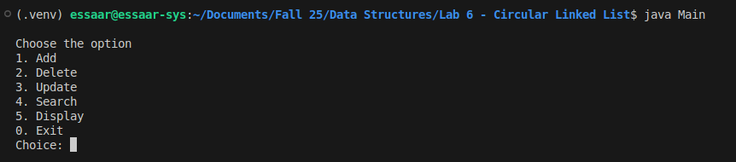
Option 1: adding new employee
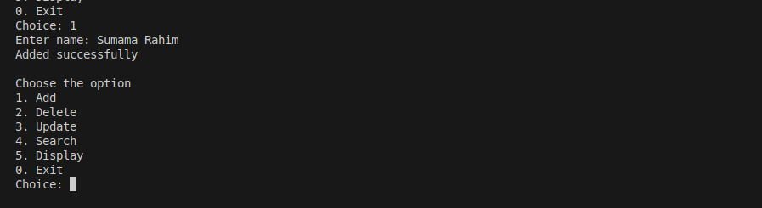
Option 2: Deleting employee
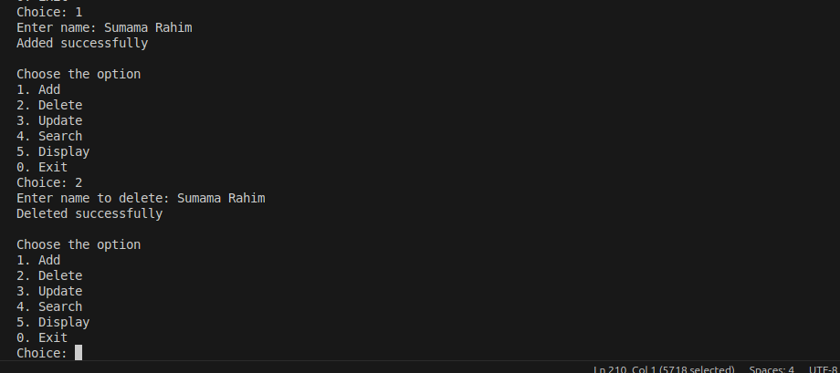
Option 3: Updating employee data
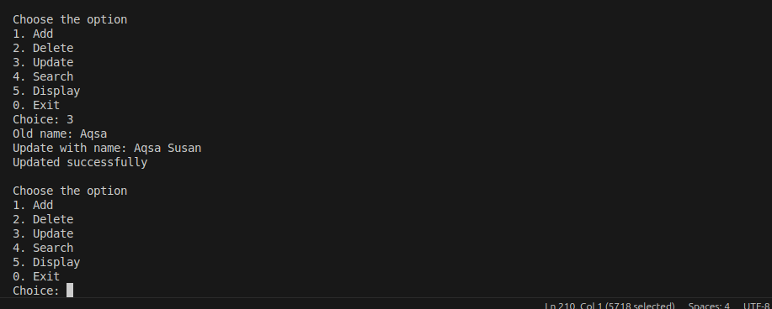
Option 4: Searching for existing employee data
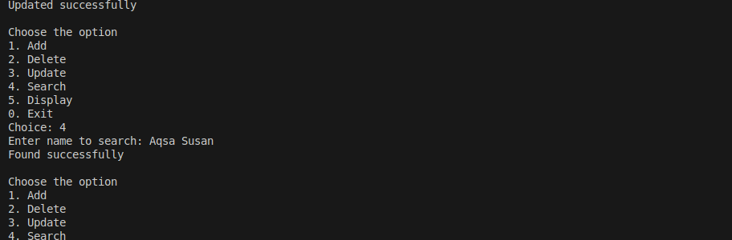
Option 5: Displaying all the employee’s data
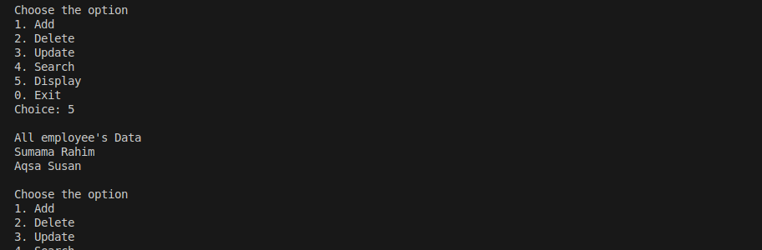
Option 6; To exit the application (by pressing 0)
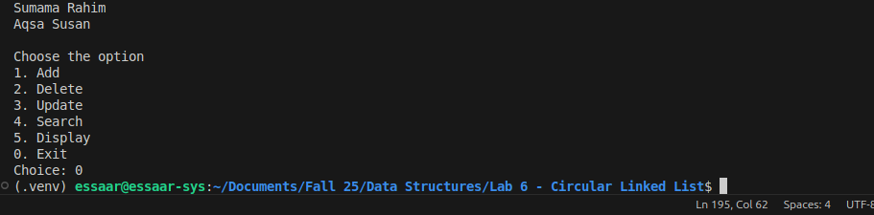
The End

